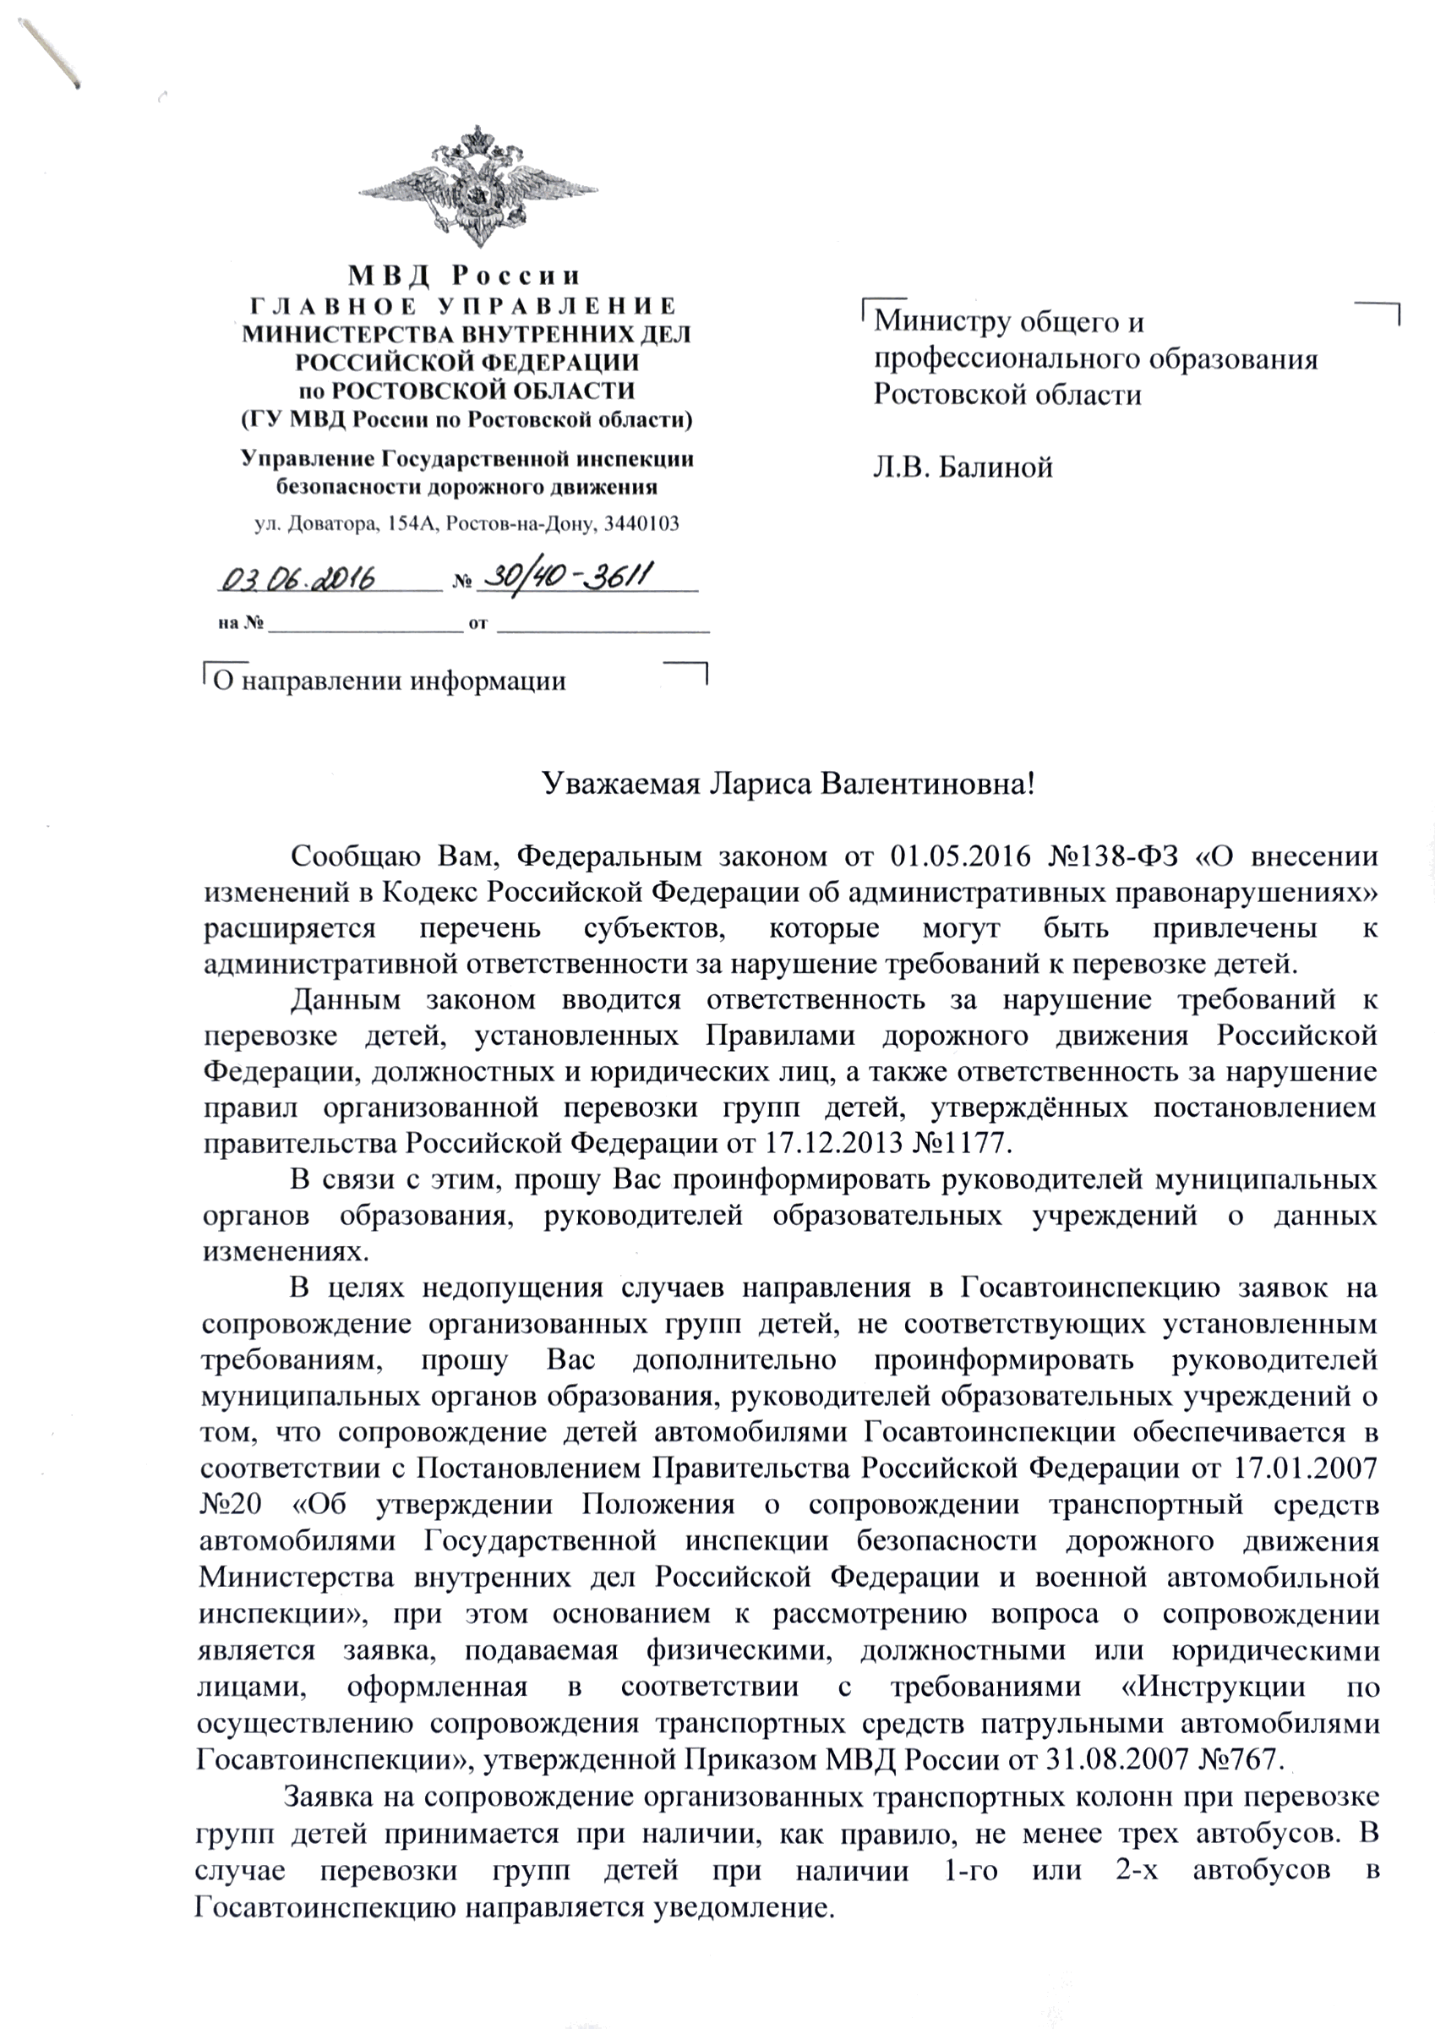

C:\Users\kislenko_zg\AppData\Local\Microsoft\Windows\Temporary Internet Files\Content.Word\image-03-06-16-09-19-1.png